 

Tech Department

C#.Net Junior Dev Challenge

[https://www.lean-tech.io](https://www.lean-tech.io/)

# Introduction

The following test aims to identify future employees by evaluating their skills, knowledge, and best practices for the .NET framework with C# technologies. The test will assess your skills based on the theoretical and practical knowledge that a Junior-level developer should have.

# Assessments

* Interpretation of problems and requirements
* Solution approach.
* Coding style.

# Assessment Description

The ﬁrst part of the test is integrated by several questions with one correct answer or multiple choices depending on the case. You must highlight the answer you think is correct with the color yellow. The 10th question is an open question for you to provide your personal opinion. The second part of the test are a series of coding challenges that you must develop within a console application in .NET Core. It must contain a menu and each option must correspond to the solutions of every task. Remember to upload this test together with the Angular test to your GitHub repository. We wish you the best of luck.

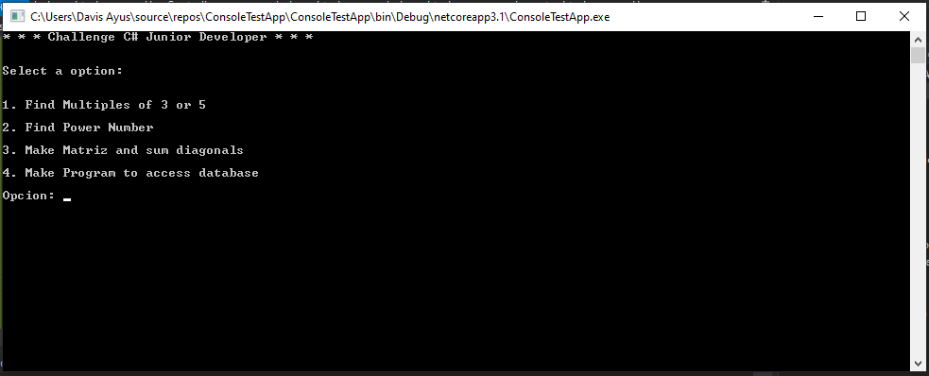

**Questions**

1. **What are the pillars of object-oriented programming ?**
   1. Objects, Classes, Attributes and Méthods.
   2. Inheritance, Polymorphism, Classes and objects.
   3. Abstraction, Encapsulation, Inheritance, Polymorphism.
2. **Select the correct instruction to add 2 numbers. They must be greater than 5 and less than 25 otherwise returns (0).**
   1. **if ((number1 > 5 && number1 < 25) && (number2 > 5 && number2 < 25)) return (number1 + number2);**

**else**

**return 0;**

**b. if ((number1 >= 5 && number1 <= 25) && (number2 >= 5 && number2 <= 25)) return (number1 + number2);**

**else**

**return 0;**

**c. if ((number1 >= 5 and number1 <= 25) or (number2 >= 5 and number2 <= 25)) return (number1 + number2);**

**else**

**return 0;**

1. **Select the correct statement to deﬁne a method that returns the sum of 2 integers.**
   1. Public suma(number1, number2) as integer
   2. int Suma(int number1, int number2)
   3. Function Suma(number1 as integer, number2 as integer) as integer
2. **Select the correct answer or answers in the following Boolean comparisons.**
   1. (true && false) = false
   2. (true || false) = true
   3. (false || true) = false
3. **Select the correct answer: What is C#?**
   1. a Microsoft Framework.
   2. An imperative programming language.
   3. An object-oriented programming language
   4. (true && false) & (true && true) = false.
   5. Todas las anteriores
      1. A framework for programming in .NET
4. **Which access modiﬁer should you use in C# if you want a method to be visible only to the classes in its assembly ?**
   1. Private
   2. Public
   3. Protected
   4. Internal
5. **How to apply inheritance in C# (The Class Employee should inherit from class Persona).**
   * 1. Public class Empleado : Persona
     2. Public class Empleado by Persona
     3. Public class Empleado Extend Persona
6. **What is Linq ?**
   * 1. Es un lenguaje de programación para base de datos.
     2. Es una librería para consultas en archivos planos.
     3. Es un lenguaje de consultas para colecciones de objetos.
     4. Todas las anteriores
7. **Create and execute a query that brings back Id_product description, measure unit, sale value in the list of prices for the public. Please keep in mind you have the following product table (id_product, description, reference, unit, percentagelva, status), price_detail (id_price_list, id_product, salevalue, discount_percentage), Prices (id_price_list, description, creation_date, expiration_date, status).**
8. **From your perspective, what is the role that software developers have in the modern world? I think software developer's role in the world is to be agents of change and force multipliers. By creating innovative and quality software, they provide people with tools to help them have a bigger productivity and impact in everything they do. In my opinion software development is behind some of the most promising changes for the future.**

Technical tasks with C#

1. **If we list all the natural numbers below 10 that are multiples of 3 or 5, we get 3, 5, 6 and 9. The sum of these multiples is 23. Make a program to calculate the sum of multiples of x or y in a number range from 1 to n.**
2. **Create a functionality within the application that allows you to ﬁnd a number in which its digits raised to the power of 5 and added together result in the initial number:**

1634 = 14 + 64 + 34 + 44

8208 = 84 + 24 + 04 + 84

9474 = 94 + 44 + 74 + 44

In this example the digits are raised to the power of 4, the sum of the result with the results of each digit are equal to the initial number. 14= (1) + 64= (1296) + 34= (81) + 44= (256) = 1634

1. **In this task you must ﬁll a matrix (of n x n elements) in the form of a spiral and then calculate the sum of their diagonals. Example (n=5) Diagonals = 101 (17+5+1+9+25+21+7+3+13) = 101**

|  |  |  |  |  |
| --- | --- | --- | --- | --- |
| **21** | **22** | **23** | **24** | **25** |
| **20** | **7** | **8** | **9** | **10** |
| **19** | **6** | **1** | **2** | **11** |
| **18** | **5** | **4** | **3** | **12** |
| **17** | **16** | **15** | **14** | **13** |

1. **Create a functionality within the application that allows you to connect to a database and show all the records of the product table (id_product, reference, description, unit, SalePrice, Status) and allows you to ﬁlter by description and status.**
2. **Make the class Person (Add attributes as appropriate), later make the classes Employee and Customer (Add the attributes that you consider necessary) and**

instance 3 objects Employee and 3 objects Customer, use the concept Inheritance.

public class Person() {

public String name;

}

public class Employee:Person (){

private float salary;

public void setSalary (string s){name = s;}

}

public class Customer:Person(){

public String residence;

}

Employee()

class TestInheritance{

public static void Main(string[] args)

{

Employee e1 = new Employee();

e1.Name = “Juan Carlos”;

e1.setSalary(10000);

Employee e2 = new Employee();

e1.Name = “Patricia”;

e1.setSalary(15000);

Employee e3 = new Employee();

e1.Name = “Sara Maria”;

e1.setSalary(10000);

Customer c1 = new Customer();

c1.Name = “Roberto”

c1.residence = “Victoria”

Customer c2 = new Customer();

c2.Name = “Juana”

c2.residence = “Cartagena”

Customer c3 = new Customer();

c3.Name = “Alejandra”

c3.residence = “Medellin”

}

}